As **Scientists**, we will be learning about ‘Everyday materials and their uses’. We will look at a range of materials that we encounter in our everyday life and observe them in the world around us. We will learn about the properties of each of the materials and then we will test these materials to see which ones are best suited to certain jobs. We will then learn about the importance of recycling and the part that we have to play in protecting the environment.

As **Artists**, we will be finding out about the life and work of the artist Georgia O’Keefe. We will look at some of her work and discuss our feelings and opinions of them. We will then use tissue paper to replicate her work ‘Oriental Poppies’.

As **Geographers**, we will be learning about our island; we will be investigating the British Isles – labelling the countries, then various regions and cities in England. We will look at the human and physical features of different areas and identify landmarks around the country. We will also learn about what we need in order to survive on our island and how our island can provide important resources for us.

**Curriculum Overview**

**Year 2**

**Autumn A 2023**

**Key Areas of Learning**

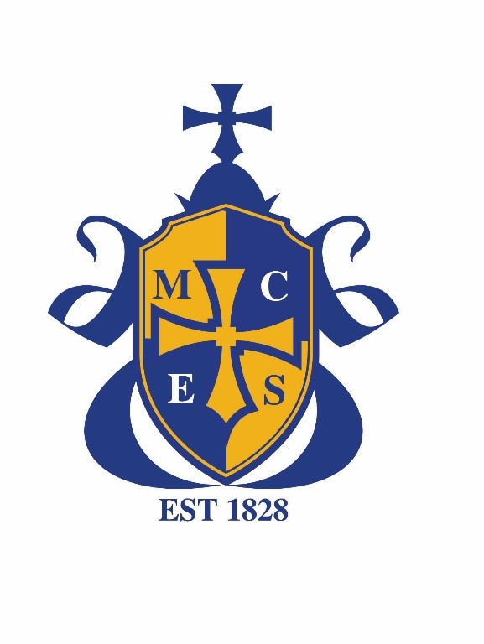

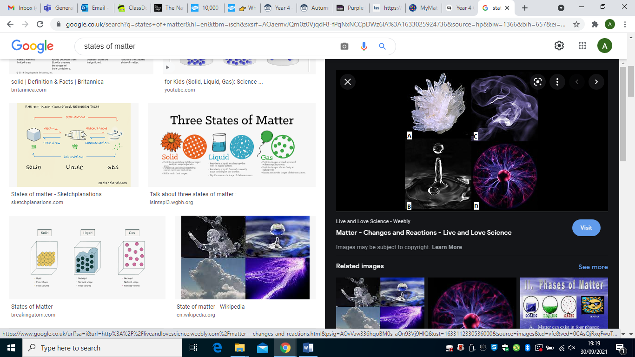

The book we will be focusing on, in our Power of Reading lessons, this half term, will be ‘The Secret Sky Garden’ by Linda Sarah.

In our Writing lessons, we will be learning about and writing a traditional tale. We will be focusing on the story of ‘The Three Little Pigs’. We will focus on capital letters, full stops and descriptive phrases.

In PSHE we will be focusing on ‘Being me in my world’. We will focus on our rights as children and look at some of the rules and responsibilities that we have.

In Maths we will be learning about place value as well as addition and subtraction. We will be looking at 2 and 3 digit numbers and practicing our recall skills of number bonds to 10 and 100. We will then be moving onto using various methods to add and subtract 2 digit numbers including column methods.

In RE our key question is ‘Why do Christians go to church? We will learn about why churches are important to many people and investigate what people like doing when they go to church.

Computing will include becoming more familiar with the keyboard and looking at coding and what that means to a programmer.

**RE**

**Computing**

**PSHE**

**MATHEMATICS**

**ENGLISH**

In PE we will be taking part in Dance lessons on Friday’s looking at movement and group work. On Thursdays, we will be learning about attacking, defending and shooting.

**Music**

We will be focusing on Music in our next half term.

**PE**

Our class value is love. We are thinking about how important it is to show love to everyone around us and how we can show the value of love in our school community.

As Geographers, we will explore the impact that humans are having on the environment across the world and what part we can play in this crisis. We will be focusing on recycling in school.

Homework is set every Friday on Purple Mash and Class Dojo. We have spellings to learn for a dictation test the following week. There is also a quiz to help with the spellings as well as maths activities and multiplication practise on Times Table Rock Stars.

Our optional homework project is for the children to choose from any of the topics we are covering this half term – they can produce a piece of work of their choice using any style or medium they would like to work with.

**Our Class Value**

**Curriculum Enrichment**

**Weekly Homework**

**Homework Project**